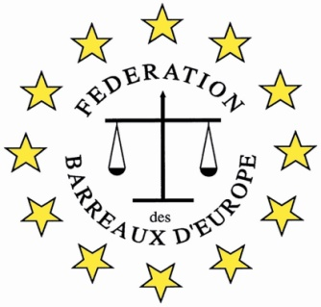

The FBE International Oratory Competition 2017

Application Form
(.doc format)

The Bar
Participating Bar
Contact Person in the Bar
Phone (international format)
E-mail
The Participant
Participant
Phone
E-mail
Additional Notes

Candidates’ applications should be approved by the Bar Association. Please contact your Bar and send your application form to a relevant person.
The Bar will send the application to the International Relations Department of the Madrid Bar Association, e-mail: internacional@icam.es, before the 28th of September 2017.

